Data Modeling

- Conceptual Data Model:

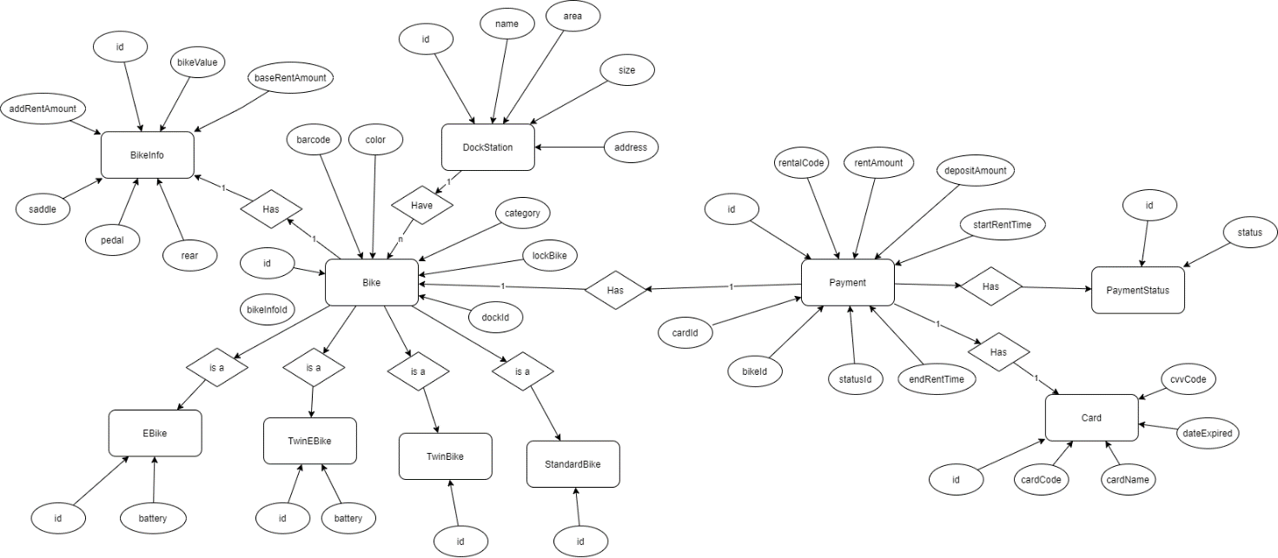

- Logical Data Model:

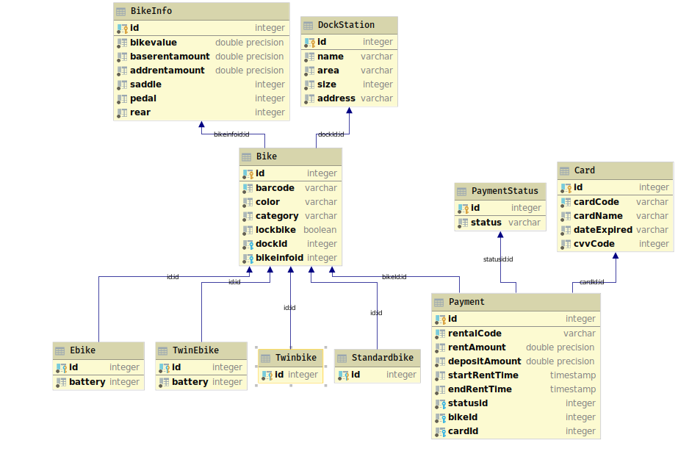

- Physical Data Model:
- BikeInfo

# | PK | FK | Column Name | Data Type | Mandatory | Description
1 | x | x | id | integer | Yes | Payment id
2 |  |  | bikeValue | double | Yes | Bike id
 |  |  | baseRentAmount | double | Yes | Base rent amount
 |  |  | addRentAmount | double | Yes | Add rent amount
 |  |  | saddle | integer | Yes | saddle
 |  |  | pedal | integer | Yes | pedal
 |  |  | rear | integer | Yes | rear
- DockStation

# | PK | FK | Column Name | Data Type | Mandatory | Description
1. | x |  | Id | Integer | Yes | ID, auto increment
2. |  |  | Name | VARCHAR | Yes | Name of dock
3. |  |  | area | VARCHAR | Yes | Area of the dock
4. |  |  | size | Integer | Yes | Max size of dock
5. |  |  | Address | VARCHAR | Yes | Address of dock

- Card

# | PK | FK | Column Name | Data Type | Mandatory | Description
1. | x | x | id | Integer | Yes | ID
2. |  |  | cardCode | VARCHAR | Yes | Card’s Code
3. |  |  | cardName | VARCHAR | Yes | Name of the card’s owner
4. |  |  | cvvCode | Integer | Yes | CVV Code of the Card
5. |  |  | dateExpired | VARCHAR | Yes | Card’s Expiration Date

- Payment

# | PK | FK | Column Name | Data Type | Mandatory | Description
1 | x |  | id | integer | yes | Payment id
2 |  |  | rentalCode | Integer | yes | Rental code
3 |  |  | rentAmount | double | Yes | Rent amount
4 |  |  | DepositAmount | double | yes | Deposit amount
5 |  |  | startRentTime | TIMESTAMP | yes | Starting rent time
6 |  |  | endRentTime | TIMESTAMP | yes | Ending rent time
7 |  | x | statusId | integer | yes | Id of status transaction
8 |  | x | bikeId | integer
9 |  | x | cardId | integer

- PaymentStatus

# | PK | FK | Column Name | Data Type | Mandatory | Description
1. | x | x | id | Integer | Yes | Payment ID
2. | x |  | status | varchar | Yes | Status of payment

- Bike

# | PK | FK | Column Name | Data Type | Mandatory | Description
1 | x |  | Id | Integer | Yes | ID, auto increment
2 |  |  | barcode | VARCHAR | Yes | Bike’s barcode
3 |  |  | color | VARCHAR | Yes | Bike’s color
4 |  |  | category | VARCHAR | Yes | Bike’s category
5 |  |  | lockBike | Boolean | Yes | Bike is locked or not
6 |  | x | dockId | integer | Yes | Bike’s dock Id
7 |  | x | bikeInfoId | Integer | Yes | Bike’s information ID
- E-Bike

# | PK | FK | Column Name | Data Type | Mandatory | Description
1. | x | x | id | Integer | Yes | Bike Id
2. |  |  | battery | Integer | Yes | Bike’s battery status
- Twin E-bike

# | PK | FK | Column Name | Data Type | Mandatory | Description
1. | x | x | id | Integer | Yes | Bike Id
2. |  |  | battery | Integer | Yes | Bike’s battery status
- Standard Bike

# | PK | FK | Column Name | Data Type | Mandatory | Description
1. | x | x | id | Integer | Yes | Bike Id
- Twin Bike

# | PK | FK | Column Name | Data Type | Mandatory | Description
1. | x | x | id | Integer | Yes | Bike Id

- Database Script:

create table "ecoBikeSystem"."DockStation"
(
id serial not null,
name VARCHAR not null,
area VARCHAR not null,
size int not null,
address VARCHAR not null
);
create unique index dockstation_id_uindex
on "ecoBikeSystem"."DockStation" (id);
alter table "ecoBikeSystem"."DockStation"
add constraint dockstation_pk
primary key (id);
create table "ecoBikeSystem"."Bike"
(
id serial not null,
barcode VARCHAR not null,
color VARCHAR not null,
category VARCHAR not null,
"bikeValue" float not null,
"baseRentAmount" float not null,
"additionalRentAmount" float not null,
lock BOOLEAN default FALSE not null
);
create unique index bike_barcode_uindex
on "ecoBikeSystem"."Bike" (barcode);
create unique index bike_id_uindex
on "ecoBikeSystem"."Bike" (id);
alter table "ecoBikeSystem"."Bike"
add constraint bike_pk
primary key (id);
create table "ecoBikeSystem"."BikeInDock"
(
"BikeId" int not null
constraint bikeindock_bike_id_fk
references "ecoBikeSystem"."Bike"
on update cascade on delete cascade,
"DockId" int not null
constraint bikeindock_dockstation_id_fk
references "ecoBikeSystem"."DockStation"
on update cascade on delete cascade,
constraint bikeindock_pk
primary key ("BikeId", "DockId")
);
create table "ecoBikeSystem"."Payment"
(
id serial not null,
"rentalCode" VARCHAR not null,
"deductAmount" float not null,
"depositAmount" float not null,
"startRentTime" TIMESTAMP not null,
"endRentTime" TIMESTAMP not null,
status int not null
);
create unique index payment_id_uindex
on "ecoBikeSystem"."Payment" (id);
create unique index payment_rentalcode_uindex
on "ecoBikeSystem"."Payment" ("rentalCode");
alter table "ecoBikeSystem"."Payment"
add constraint payment_pk
primary key (id);
create table "ecoBikeSystem"."PaymentBike"
(
"PaymentId" int not null
constraint paymentbike_payment_id_fk
references "ecoBikeSystem"."Payment"
on update cascade on delete cascade,
"BikeId" int not null
constraint paymentbike_bike_id_fk
references "ecoBikeSystem"."Bike"
on update cascade on delete cascade,
constraint paymentbike_pk
primary key ("PaymentId", "BikeId")
);
create table "ecoBikeSystem"."Card"
(
id serial not null,
"cardCode" int not null,
"cardName" VARCHAR not null,
"dateExpired" VARCHAR not null,
"cvvCode" int not null
);
create unique index card_cardcode_uindex
on "ecoBikeSystem"."Card" ("cardCode");
create unique index card_id_uindex
on "ecoBikeSystem"."Card" (id);
alter table "ecoBikeSystem"."Card"
add constraint card_pk
primary key (id);
create table "ecoBikeSystem"."PaymentCard"
(
"PaymentId" int not null
constraint paymentcard_payment_id_fk
references "ecoBikeSystem"."Payment"
on update cascade on delete cascade,
"CardId" int not null
constraint paymentcard_card_id_fk
references "ecoBikeSystem"."Card"
on update cascade on delete cascade,
constraint paymentcard_pk
primary key ("PaymentId", "CardId")
);
create table "ecoBikeSystem"."Ebike"
(
id int not null
constraint ebike_pk
primary key
constraint ebike_bike_id_fk
references "ecoBikeSystem"."Bike"
on update cascade on delete cascade,
battery int not null
);
create table "ecoBikeSystem"."TwinEbike"
(
id int not null
constraint twinebike_pk
primary key
constraint twinebike_bike_id_fk
references "ecoBikeSystem"."Bike"
on update cascade on delete cascade,
battery int not null
);
create table "ecoBikeSystem"."Standardbike"
(
id int not null
constraint standardbike_pk
primary key
constraint standardbike_bike_id_fk
references "ecoBikeSystem"."Bike"
on update cascade on delete cascade
);
create table "ecoBikeSystem"."Twinbike"
(
id int not null
constraint twinbike_pk
primary key
constraint twinbike_bike_id_fk
references "ecoBikeSystem"."Bike"
on update cascade on delete cascade
);

